LAB # 3
Interfacing button with MSP430 microcontroller and polling based Night rider



Spring 2025
CSE-307L

Microprocessor Based System Design Lab

Submitted by: Naveed Ahmad
Registration No.: 22PWCSE2165
Class Section: B

Student Signature: ______________

Submitted to:
Engr. Shah Zada Fahim Jan
March 16, 2025

Department of Computer Systems Engineering
University of Engineering and Technology, Peshawar

TASK1:
write a program which monitor a switch if it is pressed then toggle LED attach with P1.0
CODE:
int main(void) {
WDTCTL = WDTPW | WDTHOLD; // Stop watchdog timer
PM5CTL0 &= ~LOCKLPM5; // Enable GPIOs
P1DIR |= 0x01; // Set P1.0 as output (LED)
P1DIR &= ~0x04; // Set P1.2 as input (Switch)
P1OUT |= 0x04; // Pull-up resistor on P1.2
P1REN |= 0x04; // Enable resistor on P1.2
while(1) {
if (!(P1IN & 0x04)) { // If switch is pressed mean condition P1.2 goes low and condtion will true
P1OUT ^= 0x01; // Toggle LED on P1.0
__delay_cycles(100000);
}
}
}
OUTPUT:

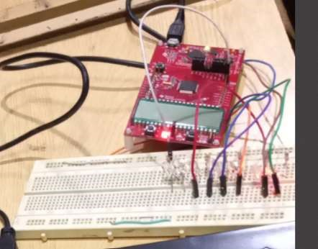

TASK2:
write a program which monitor a switch if it is not pressed then toggle LED attach with P1.0 if it is pressed then stop toggling.
#include <msp430.h>
CODE:
#include <msp430.h>
int main(void) {
WDTCTL = WDTPW | WDTHOLD; // Stop watchdog timer
PM5CTL0 &= ~LOCKLPM5; // Enable GPIOs
P1DIR |= 0x01; // Set P1.0 as output (LED)
P1DIR &= ~0x04; // Set P1.2 as input (Switch)
P1OUT |= 0x04; // Pull-up resistor on P1.2
P1REN |= 0x04; // Enable resistor on P1.2
while(1) {
if (P1IN & 0x04) { // If switch is NOT pressed mean P1.2 will high
P1OUT ^= 0x01; // Toggle LED on P1.0
__delay_cycles(100000); // Toggle speed
}
}
}

OUTPUT:
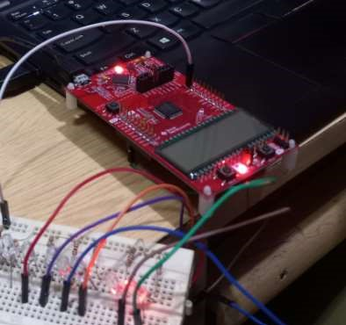
TASK3:
write a program which monitor a switch if the switch is pressed the LED if on should off and if off should ON.
CODE:
int main(void) {
WDTCTL = WDTPW | WDTHOLD; // Stop watchdog timer
PM5CTL0 &= ~LOCKLPM5; // Enable GPIOs
P1DIR |= 0x01; // Set P1.0 as output (LED)
P1DIR &= ~0x04; // Set P1.2 as input (Switch)
P1OUT |= 0x04; // Pull-up resistor on P1.2
P1REN |= 0x04; // Enable resistor on P1.2
while(1) {
if (!(P1IN & 0x04)) { // If switch is pressed
P1OUT ^= 0x01; // Toggle LED on P1.0
while (!(P1IN & 0x04)); // Wait for switch release
__delay_cycles(100000); // Debounce delay
}
}
}
OUTPUT:
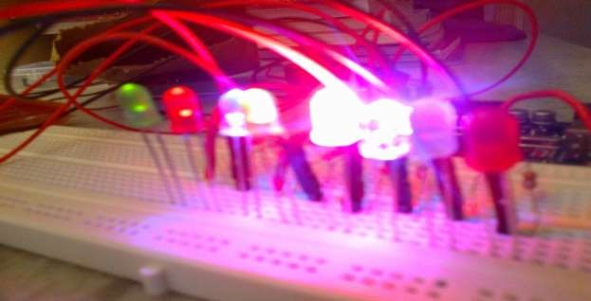

TASK4:
Write a program which monitors a switch. If it is not pressed, then toggle the LED attached with P1.0. If it is pressed, then stop toggling.
CODE:
#include <msp430.h>
int main(void) {
WDTCTL = WDTPW | WDTHOLD; // Stop watchdog timer
PM5CTL0 &= ~LOCKLPM5; // Enable GPIOs
P1DIR |= 0x01; // Set P1.0 as output (LED)
P1DIR &= ~0x04; // Set P1.2 as input (Switch)
P1OUT |= 0x04; // Pull-up resistor on P1.2
P1REN |= 0x04; // Enable resistor on P1.2
while(1) {
if (P1IN & 0x04) { // If switch is NOT pressed
P1OUT ^= 0x01; // Toggle LED on P1.0
__delay_cycles(100000);
}
// If the switch is pressed, do nothing (stop toggling)
}
}
OUTPUT:

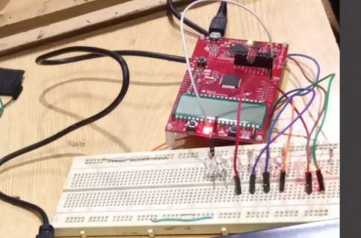

Task 05:
NIGHT RIDER CODE:
#include <msp430.h>
int main(void) {
WDTCTL = WDTPW | WDTHOLD; // Stop watchdog timer
PM5CTL0 &= ~LOCKLPM5;
P8DIR |= 0xFF; // Set all 8 pins of Port 8 as output
P1DIR &= ~0x04; // Set P1.2 as input (Switch)
P8OUT = 0x00; // Start with all LEDs off
P1REN |= 0x04; // Enable pull-up resistor on P1.2
P1OUT |= 0x04; // Pull-up resistor active
unsigned char pattern = 0x01; // Start with the first LED
while (1) {
if (!(P1IN & 0x04)) { // If switch is pressed
__delay_cycles(100000); // Debounce delay
P8OUT = pattern; // Turn on current LED
__delay_cycles(100000); // Blink delay
P8OUT = 0x00; // Turn off all LEDs __delay_cycles(100000); // Off delay pattern <<= 1; // Shift pattern to the next LED
if (pattern == 0x00) { // If pattern goes beyond P8.7 pattern = 0x01; // Reset to the first LED
}
} else {
P8OUT = 0x00; // Turn off all LEDs when switch is not pressed
}
}

return 0;
}
Output:

